**YEAR 11 ATAR HUMAN BIOLOGY**

**TASK 15: GENETICS & INHERITANCE TEST**

**PART 1 MULTIPLE CHOICE (20 MARKS):**

1. A human female would have which of the following sex chromosomes in her body cells?
   1. XY
   2. XX
   3. YY
   4. XYX
2. A pure breeding black mouse is mated with a pure breeding brown mouse. The first generation is all black and when they are mated amongst themselves the next generation includes both black mice and brown mice. Of the mice in the F1 generation:
   1. None carry genes for brown fur.
   2. About one-quarter carry genes for brown fur.
   3. Half of them carry genes for brown fur.
   4. All of them carry genes for brown fur.
3. A man is unsure of his parentage to a new born baby. What test can be done to determine his parentage with a high amount of certainty?
4. blood test
5. urine test
6. amniocentesis
7. DNA profiling
8. An allele that is not expressed in a heterozygous genotype is called:
   1. recessive
   2. dominant
   3. genotypic
   4. phenotypic
9. An autosome is
   1. A sex chromosome
   2. Any of the chromosomes that is not a sex chromosome
   3. A chromosome that always stays the same
   4. A chromosome that has mutated
10. Which punnett square shows the offspring of a heterozygous autosomal father with a homozygous autosomal recessive mother?

a. b. c. d.

Hh hh

Hh hh

Hh Hh

Hh HH

Hh Hh

Hh Hh

HH HH

HH HH

1. A pair of homologous chromosomes
   1. are identical in their gene content
   2. carries all recessive genes on one chromosome and dominant genes on the other
   3. is transmitted as a pair to the sperm or ovum
   4. carries pairs of genes concerned with the same physical characteristics
2. If a white flower(WW) is crossed with a red flower(RR), the probable offspring will be
   1. all pink(RW)
   2. all white(WW)
   3. all red(RR)
   4. ¾ white(WW) and ¼ red(RR)
3. Inheritance of mitochondrial DNA
   1. Is dependent on having DNA input from both parents
   2. Is inherited through the father
   3. Is inherited through the mother
   4. Is randomly inherited from either parent
4. Which of the pedigrees below is consistent with the inheritance of a recessive characteristic controlled by a gene on the **X chromosome**? Shaded individuals possess the trait.

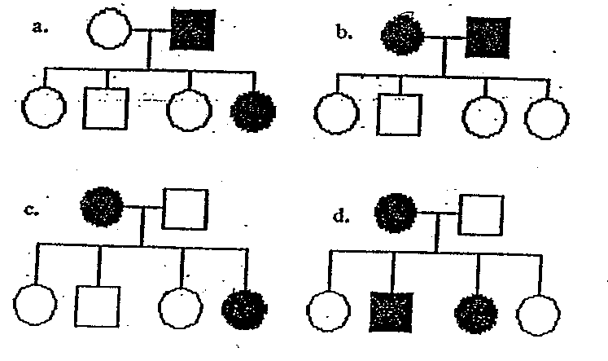

1. Red-green colour-blindness is an X-linked recessive disorder. A mother with this condition will pass this allele to
2. her daughters only
3. all of her children
4. her sons only
5. none of her children



What is the most likely mode of inheritance for the shaded characteristic shown in the diagram above?

1. autosomal dominant
2. autosomal recessive
3. X --linked recessive
4. X- linked dominant
5. The incidence of Huntington’s Disease, an autosomal dominant condition, is approximately one in every 10 000 births. What is the probability of a male having this condition if the mother has the condition but his father does not? Of all of his grandparents, only his grandmother on his mother’s side has the condition as well.
   1. ½
   2. ¼
   3. ¹/5000
   4. ¾
6. Tongue rolling is a characteristic controlled by a single autosomal dominant gene. A heterozygous tongue rolling man marries a non-tongue rolling female and produces 3 boys and 3 girls. The pedigree is shown below. (Shaded individuals can tongue roll)

The probability that a child has the genotype of Tt is

1. 0%
2. 25%
3. 50%
4. 100%
5. An allele is best defined as
6. a lethal recessive phenotype
7. a lethal dominant phenotype
8. a type of gene only found on one sex chromosome
9. an alternative form of a gene at a given locus
10. If two individuals belong to Group **AB** and Group **O** respectively, then their offspring would belong to blood group:
11. O
12. AB
13. A or B
14. AB, A, or B
15. A person’s blood group (A, B, AB or O) is an example of:
    1. a genotype.
    2. a hybrid.
    3. a phenotype.
    4. polygenic inheritance.

**The following three questions refer to the pedigree below**.

**I**

**II**

**III**

**IV**

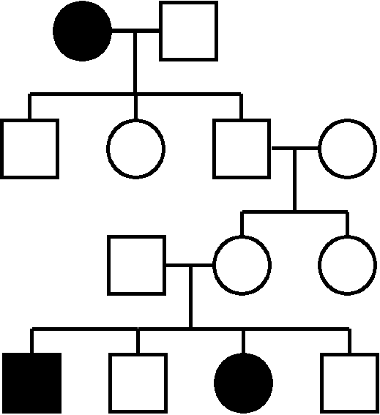

1. What is the most likely mode of inheritance of this trait?
2. Autosomal recessive
3. Sex linked recessive
4. Autosomal dominant
5. There is not enough information to be sure
6. What is the probability that any further children from the parents in generation III will have the trait?
7. 0.5
8. 0.25
9. 1.0
10. 0
11. Which of the following could be a trait represented by the pedigree?
12. Haemophilia
13. Cystic fibrosis
14. Huntington’s disease
15. Down syndrome

***END OF PART 1***

**YEAR 11 ATAR HUMAN BIOLOGY**

**TASK 15: GENETICS & INHERITANCE TEST**

**NAME :**

**MULTIPLE CHOICE ANSWER SHEET**

*Place a × through the correct answer.*

1. [A] [B] [C] [D]

2. [A] [B] [C] [D]

3. [A] [B] [C] [D]

4. [A] [B] [C] [D]

5. [A] [B] [C] [D]

6. [A] [B] [C] [D]

7. [A] [B] [C] [D]

8. [A] [B] [C] [D]

9. [A] [B] [C] [D]

10. [A] [B] [C] [D]

11. [A] [B] [C] [D]

12. [A] [B] [C] [D]

13. [A] [B] [C] [D]

14. [A] [B] [C] [D]

15. [A] [B] [C] [D]

16. [A] [B] [C] [D]

17. [A] [B] [C] [D]

18. [A] [B] [C] [D]

19. [A] [B] [C] [D]

20. [A] [B] [C] [D]

**PART 2: SHORT ANSWERS (30 MARKS):**

1. Explain the differences between:  
   1. Genotype and Phenotype  
        
       Genotype is the genetic makeup of an individual as determined by the alleles for a particular characteristic, [1] while phenotype is the physical appearance of the characteristic being considered. [1]
   2. Homozygous and Heterozygous  
        
       Homozygous is when an individual has the same alleles for a particular characteristic[1] while heterozygous is when an individual as determined by the expression of the alleles for that characteristic.[1]

(4 marks)

1. What is meant be sex-linked (X-linked) inheritance?  
     
    Sex-linked inheritance is when the gene[1] is found on the x-chromosome[1].

(2 marks)

1. Explain why a man who has a sex-linked disorder, can’t pass it on to his sons.  
     
    A man passes his Y chromosome to his sons[1], so if he has a sex-linked disorder, the allele will be on his x-chromosome and only go to daughters [1]

(2 marks)

1. Cystic Fibrosis (CF) is an autosomal recessive disorder. A couple with a history of CF in their families undergo genetic counselling before trying to conceive a baby.
2. It is found that the man is a carrier for CF and the woman is homozygous normal. Predict the possible genotypes and phenotypes of their future children. (3 marks)

Let F be normal and f be cystic fibrosis allele

Parents’ phenotypes: normal female × normal male( or carrier male - either ok)

Parent’s genotypes: FF × Ff

|  |  |  |
| --- | --- | --- |
|  | F | F |
| F | FF | FF |
| f | Ff | Ff |

F1 genotypes: 2/4 FF, 2/4 Ff

F1 phenotypes: All normal (2/4 carriers)

[2] Punnett square

[1] answer – genotypes and phenotypes

1. The genetic counsellor drew a pedigree to show the couple how CF has been inherited in their families. In the space provided, construct the pedigree diagram the counsellor would have drawn. Include:

* three labelled generations
* the couple’s parents
* the couple and their siblings. The man has an older sister; his sister was affected with CF. The woman is the oldest child, with a younger sister and an even younger brother who are unaffected
* the prediction of three future children, who are all boys. (3 marks)

[2] for correct pedigree including labelled generations (1/2 off if not labelled some way)

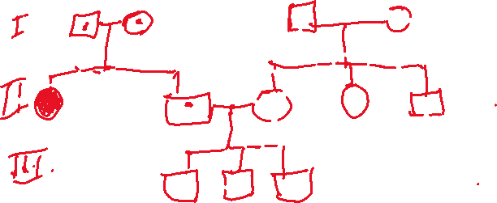

[1/2] for carriers and [1/2] affected person clearly marked

1. Below is a pedigree chart showing a family history of haemophilia

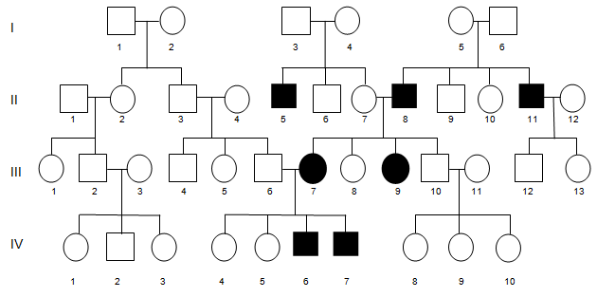

1. Using the pedigree chart, determine the mode of inheritance. Explain how you were able to determine this.  
     
   Sex-linked recessive [1]

Recessive because it skips generations for example parents I3 and I4 don’t have the disease, but their son II5 does. (any other relevant example)[1]

Sex-linked because there is no history of haemophilia in III6’s family, so not likely a carrier.[1]

(2 marks)

1. Determine the probability that person **III: 12** will inherit haemophilia. Show all working in your answer.

Let H be normal and H Haemophilia

Parents’ phenotypes: normal female × haemophiliac male

Parents’ genotypes: XHXH × XhY

|  |  |  |
| --- | --- | --- |
|  | XH | XH |
| Xh | XHXh | XHXh |
| Y | XHY | XHY |

F1 Genotypes: 2/4 XHXh, 2/4 XHY

F1 phenotypes:2/4 normal (carrier) female, 2/4 normal male.

Therefore 0% chance that child will inherit haemophilia

[2] Punnett square

[1] answer

(accept 25% if they include possibility mother is heterozygous)

(3 marks)

1. A man has blood group A and his wife has blood group B. They have two children – a daughter who has blood group O and a son who has blood group AB. Explain how this is possible. ***Show your working.*** (4 marks)

If both parents are heterozygous, then:

Parents’ phenotypes: A blood × B blood

Parents’ genotypes: IAi × IBi

|  |  |  |
| --- | --- | --- |
|  | IA | i |
| IB | IAIB | IBi |
| i | IAi | ii |

F1 genotypes: ¼ IAIB, ¼ IBi, ¼ IAi, ¼ ii

F1 phenotypes: ¼ AB blood, ¼ B blood, ¼ A blood and ¼ O blood.

Therefore, if both parents are heterozygous then it is possible to have children with any blood group. So it is possible for them to have a daughter with blood group O and a son with blood group AB.

[1] for parents’ genotypes

[2] for Punnett square

[1] for summary of results

1. The pedigree below traces the inheritance of neurofibromatosis. **Neurofibromatosis** (**NF**) refers to a number of inherited conditions that are clinically and genetically distinct and carry a high risk of tumor formation, particularly in the brain. Affected individuals, indicated here by the filled-in circles and squares, show symptoms of this condition.

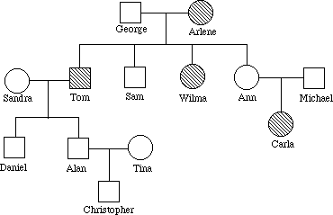

1. Is the pedigree dominant or recessive?

__Recessive________________________________________________________________

(1 mark)

1. Use the information in the pedigree to provide a reason for your answer above  
     
    It skips a generation - Ann and Michael don’t have it, but their daughter Carla does [1]

(1 mark)

1. Using 'N' for dominant and 'n' for recessive, what is the genotype for:

George Nn [1]

(1 mark)

1. If Carla was to marry a heterozygous individual, what is the probability that they could have a child with neurofibromatosis? Using a punnet square in the space below, show all your working, including the phenotypes and genotypes of all individuals involved.

(4 marks)

Parents’ phenotypes: affected female × normal (carrier) male

Parents’ genotypes: nn × Nn

|  |  |  |
| --- | --- | --- |
|  | n | n |
| N | Nn | Nn |
| n | nn | nn |

F1 genotypes: 2/4 Nn, 2/4 nn

F1 phenotypes: 2/4 normal (carrier), 2/4 affected

Therefore, the probability they will have a child with neurofibromatosis is 50%.

Parents’ phenotypes and genotypes [1]

Punnett square [1]

F1 genotypes and phenotypes [1]

Answer [1]

Note: they don’t have to include “carrier” in phenotypes.

***END OF TEST***